Installation Guide

XAMPP

1. Go to <https://www.apachefriends.org/index.html> and download XAAMP.
2. Double-click file to run the installer.
3. Click Next. It’s at the bottom of the setup window.

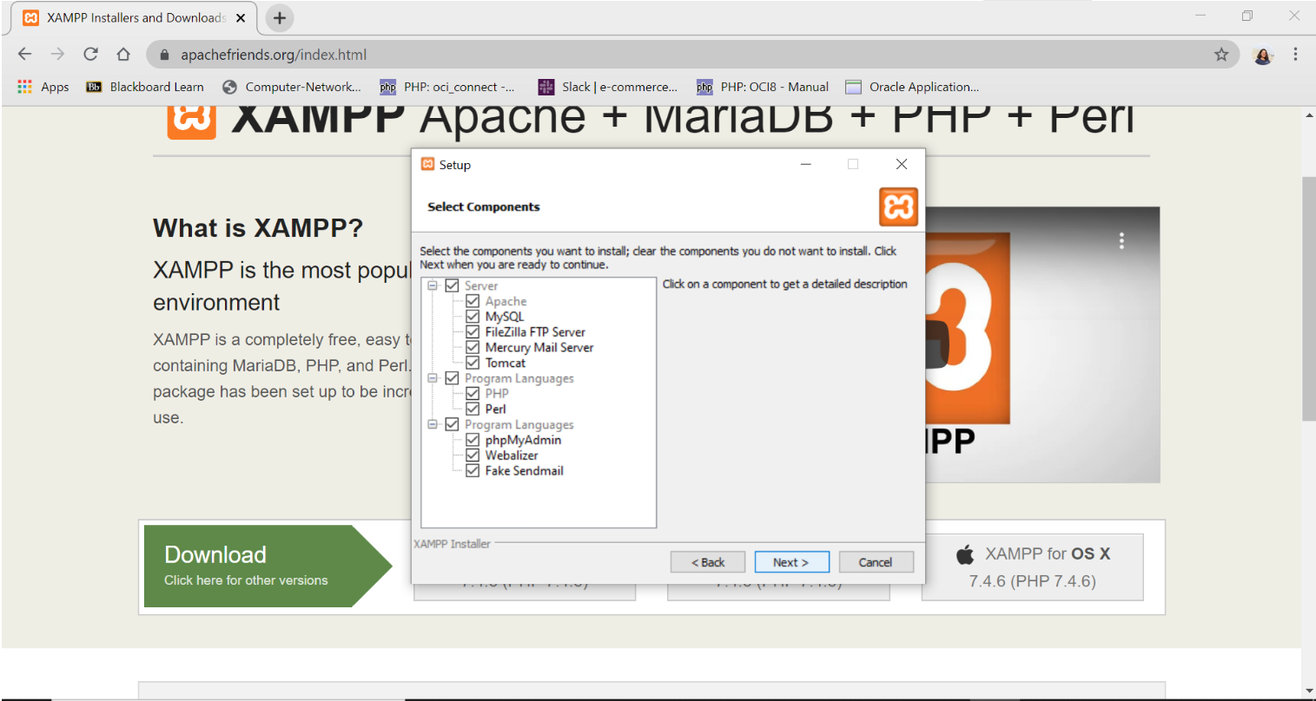

1. Choose a folder to install XAMPP and click Next.

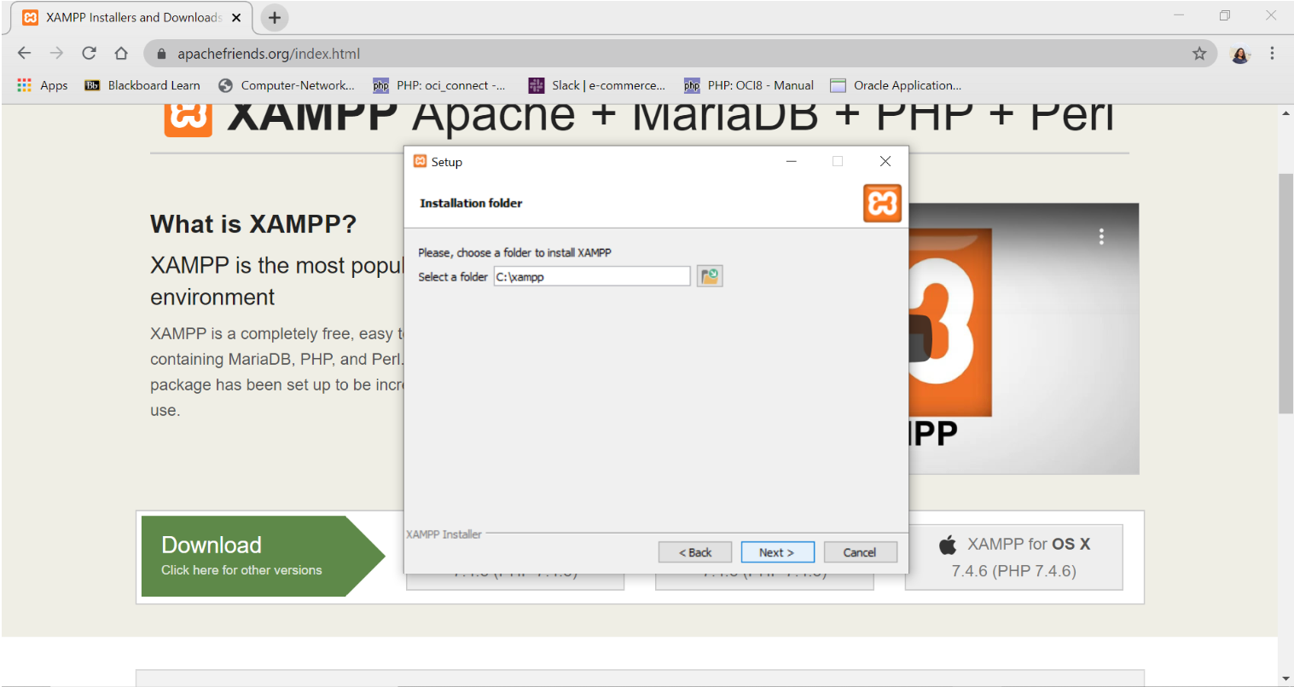

5. Begin Installing XAMPP. Click next at the bottom of the window to do so. XAMPP will begin installing its files into the folder that you selected.

6. Click finish when prompted. Doing so will close the window and open the XAMPP Control Panel, which is where you’ll access your servers.

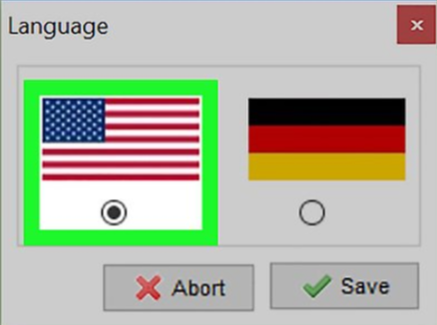

7. Select a language. Check the box next to American flag for English, or check the box next to the German flag for German.

8.Click Save. Doing so opens the main Control Panel page.

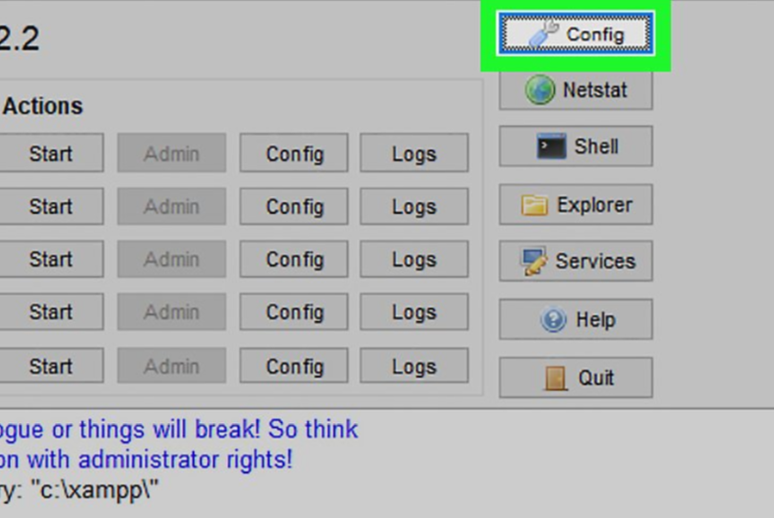

9. Resolve issues with Apache refusing to run. On some Windows 10 computers, Apache won’t run due to a “blocked port”. This can happen for a couple of reasons, but there’s a relatively easy fix.

* Click **Config** to the right of the Apache heading.
* Click **Apache (httpd.conf)** in the menu.
* Scroll down to the “Listen 80” section (you can press Ctrl + F and type in listen 80 to find it faster).
* Replace 80 with any open port (e.g., 81 or 9080).
* Press Ctrl + S to save the changes, then exit the text editor.
* Restart XAMPP by clicking Quit and then re-opening in administrator mode from its folder.